

**National University of Computer and Emerging Sciences**

Software Engineering

**“final-report”**

**E-Learning System**

**STUDENTS NAME AND REGISTRATION NUMBERS:**

Muhammad Umaid Khakwani i19-0666

Hanzla Sibghat i19-0505

Saad Ahmad Jilani i19-0615

**DEGREE PROGRAM:** BS-CS-2019

**SECTION:** D

**SUBJECT NAME:** Software Engineering

**DATE OF SUBMISSION: May 23, 2022**

**SUBMITTED TO:** Dr. Maryam Abdul Ghafoor

__**____________________________________________________________**

# GitHub link:

<https://github.com/umaidkhakwani/E-Learning-system/tree/main/project>

**1.Introduction:**

Our project is online Learning Management System. It allows a user to sign in and access online study material. We have teachers of different subject which upload course material according to their respective subjects which is then accessed by the students. The students give exam and if they pass the exam they will receive a certificate for their efforts. The admin of the system looks over all the users and can make change to the user’s data if they want to.

**2.Rational:**

The rational behind our project is to make an appropriate LMS system which can handle all type of things. An all in one LMS system. Most of the LMS systems lacks some features and its very difficult to sync multiple systems available so our goal is to make an LMS system which contains most of the required features.

**3.Architecture:**

We have used MVC architecture in our project for E-Learning system.

PHP MVC is an application design pattern that separates the application data and business logic (model) from the presentation (view). MVC stands for Model, View & Controller.

Model – this part is concerned with the business logic and the application data. It can be used to perform data validations, process data and store it. The data can come from database or other valid sources.

Controller – this is the part deals with the users’ requests for resources from the server.

As an example, when the users requests for the URL …/index.php?products, the controller will load the products model to retrieve the products data then output the results in the list view.

Views – this part deals with presenting the data to the user. This is usually in form of HTML pages.

• Front controller – this is the part that responds to URL requests and returns the requested page. This code will go into the controller

• Model – this is the code that responds to data requested and returns the requested data. This code will go into the model

• Views – this is the code responsible for formatting and displaying the data. This code will go into the view

**4.Product Backlog**

*APP USER (admin, student, teacher)

|  |  |  |  |  |
| --- | --- | --- | --- | --- |
| **ID** | **User Stories** | **Estimate** | **Priority** | **Acceptance criteria** |
| 1 | As an App User I want to register in the system so that I can learn or teach | 9 hours | 1 | * click register button then I can access all services * on signup page I should fill username (should be alpha numeric) and password (at least 8 characters with 1 uppercase) with birthdate, and degree program |
| 2 | As a student I want to enroll in the courses so that I can learn the course | 5 hours | 3 | * select the course (drop down menu according to selected degree program) * click register then I can take classes of that course |
| 3 | As a App User I want to take help with chatting with chatbot so that I can understand the site better. | 6 hours | 15 | * click on request chatbot then a window opens * we can send message and query to the chatbot. |
| 4 | As a student I want to take my exam reports so that I can figure out my progress | 6 hours | 18 | * when I click to get report, it prints the report on the screen * we can take screenshot of it |
| 5 | As a student I want to take my certificate in the end of course with a grade on it, so that I can push it on my CV | 5 hours | 17 | * After the course ends we can click on get certificate to print the certificate of that course with remarks. |
| 6 | As a teacher I want to make exams for the student so that I can make improvement in the knowledge of the students | 5 hours | 13 | * After the teacher is assigned to a course, he/she can create the exam paper in data base * we can upload it to the exam section |
| 7 | As a student I want to give rating to the teacher of the registered course | 6 hours | 19 | * Student can give rating by clicking on rating button * teacher can see the rating send by students |
| 8 | As a student, I want to get updated by the daily popup notification or any update so that I remain updated all the time. | 6 hours | 16 | * The student receives a pop-up notification. |
| 9 | As a student I want to see the dashboard so that I can see my attendance, marks and grades in respective courses on it | 6 hours | 6 | * By clicking the dashboard button, students can see their grades, marks and attendance on the dashboard. |
| 10 | As an admin I want to see all the records of teachers and students so that I can make changes according to it | 5 hours | 7 | * The admin can see the updated information and also make changings in each section. |
| 11 | As a App User I want to sign in (if existing user) so that I can access my account | 5 hours | 2 | * After signing in, App user fills username to access his/her account |
| 12 | As a admin I can upload motivational quotes so that teachers and students remain motivated | 4 hours | 12 | * Student and teacher can view the motivational quotes updated by the admin |
| 13 | As a student I want to access the course material offline so that I can learn without internet | 5 hours | 10 | * Student can download course videos from webpage by clicking download option under video |
| 14 | As a student I want to make a query to teacher | 4 hours | 11 | * Student can post their query to respected course instructor * instructor can see and reply to the query |
| 15 | As a student I want to mark my attendance according to the time I am active on LMS | 6 hours | 5 | * the system tracks a student’s active time if It is greater than 15 mins the student is marked present |
| 16 | As a student I want to keep some course material as favorite’s so I can easily access them | 5 hours | 20 | * Student favorite section is updated with the material so that he/she can access it later |
| 17 | As a student I want to discuss course material with other student and teachers in a group | 5 hours | 21 | * Group chat box is made and members are added |
| 18 | As a admin I want to take suggestions from students and teachers for the improvement of the LMS | 6 hours | 22 | * Student and teachers can send suggestions in compliant box |
| 19 | As an admin I want to rank the courses according to the maximum grades achieved in the course | 6 hours | 23 | * Course ranking will be updated and student can view and register according to course ranking |
| 20 | As an admin I want to provide students with additional reference material linking to other websites | 4 hours | 9 | * Student can access different sites through the links provided |
| 21 | As a student I want to pay for the registered course | 5 hours | 4 | * After selection of course the student gives acc number in order to register in course |
| 22 | As an teacher I want to upload course material so that student can access the videos and pdf | 4 hours | 8 | * After registration of course student can see the course materials |
| 23 | As a student I want to take exam at the end of course so that I can finish course. | 4 hours | 14 | * After the student submits the paper the teacher will mark paper and give grade. |
| 24 | As a student I can update my credentials. | 3 hours | 24 | * After registration, the student can update his/her credentials. |
| 25 | As a teacher I want to give assignments to the students so that I can keep track on student progress | 5 hours | 25 | * After teacher upload the assignment student will be able to access the pdf of assignment |

# 5.Gantt Chart:

# 5.Project Planning:

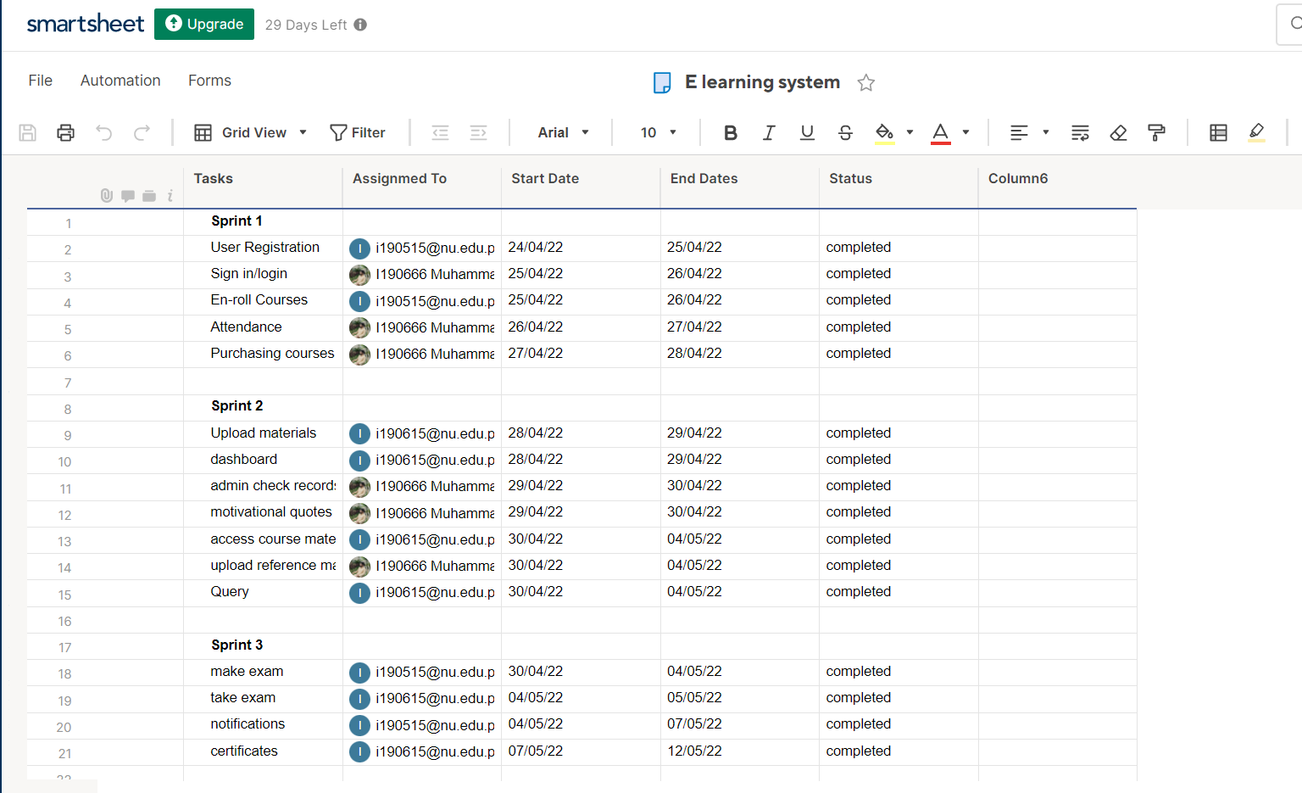

# 6.Product burndown chart:

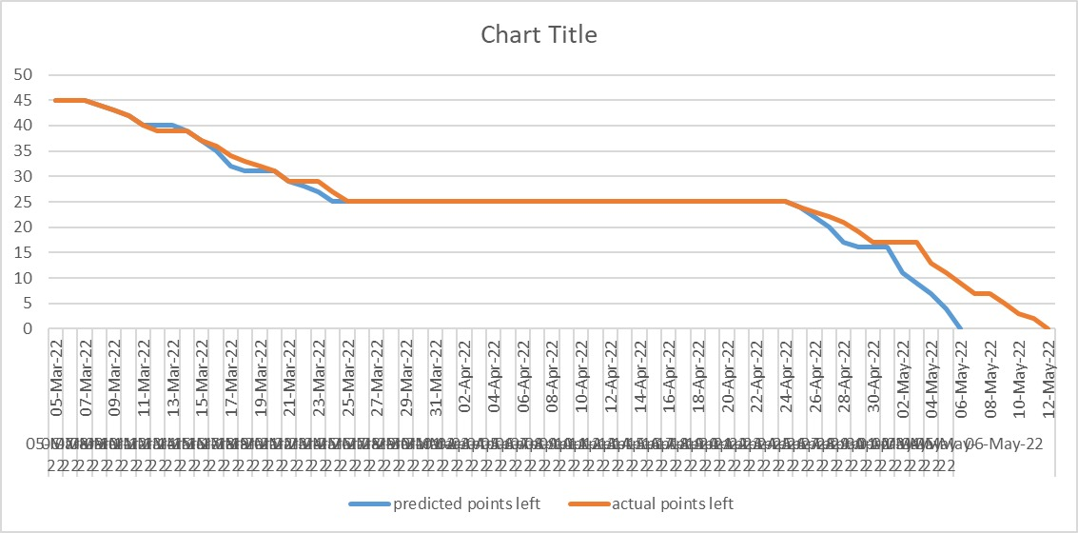

**7.Trello screenshot:**

Sprint 1:

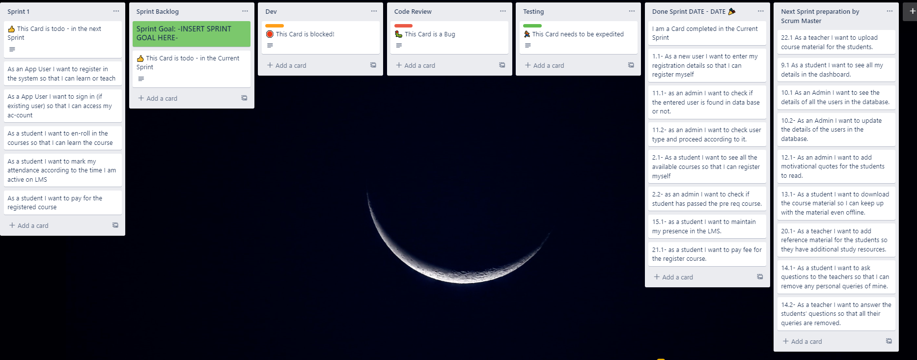

Sprint 2:

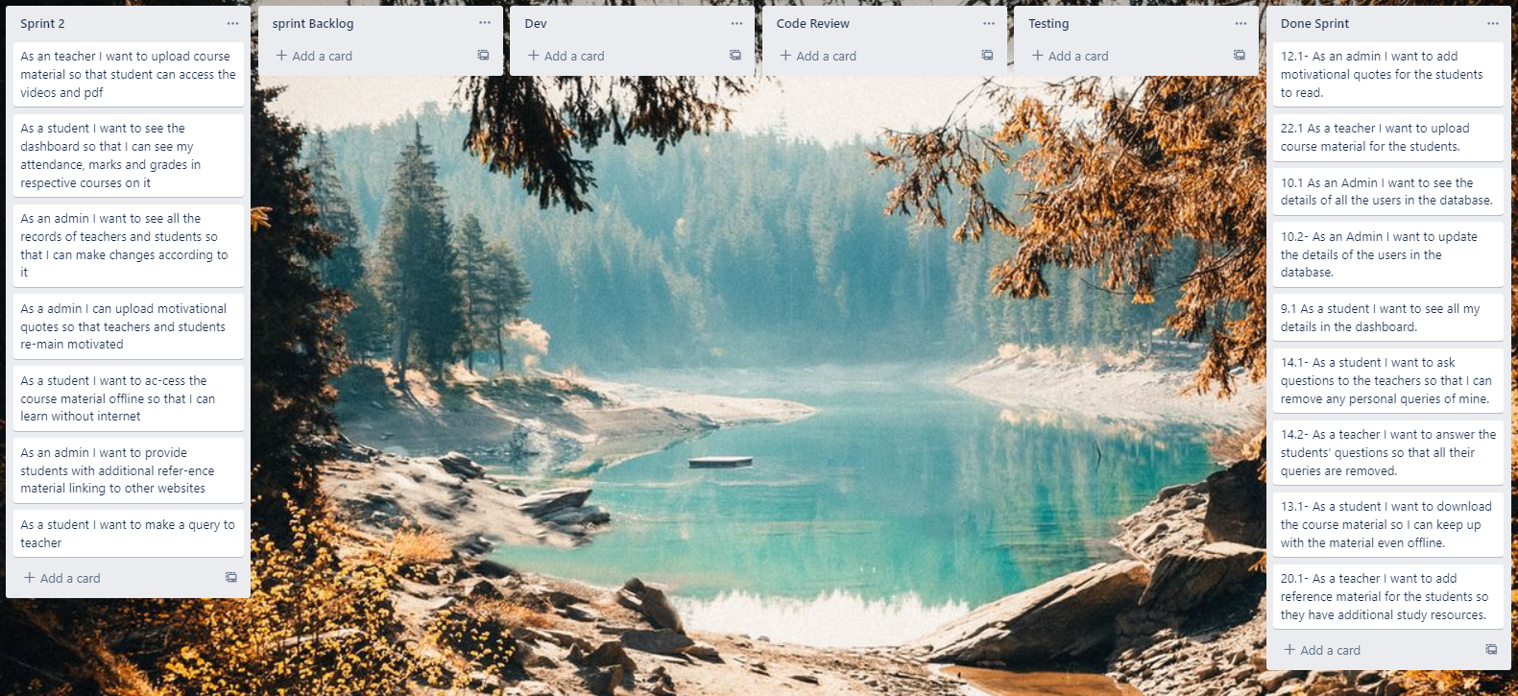

Sprint 3:

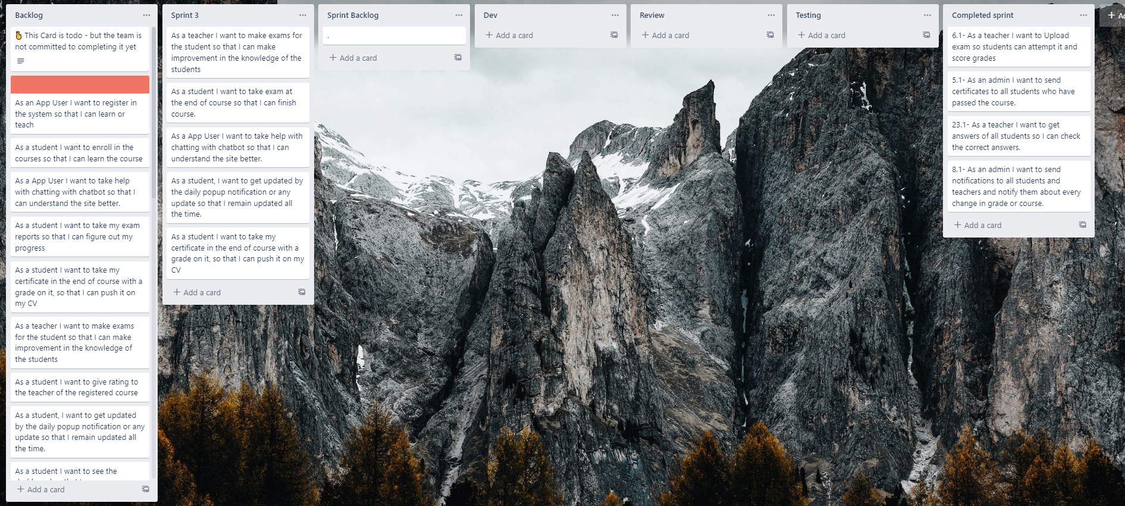

# 8.GUI

Database:

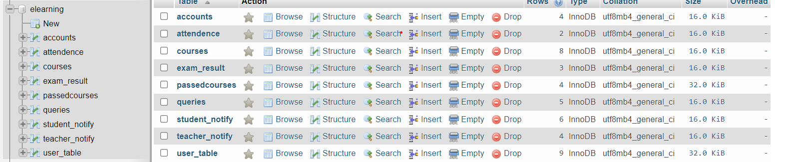

Homepage:

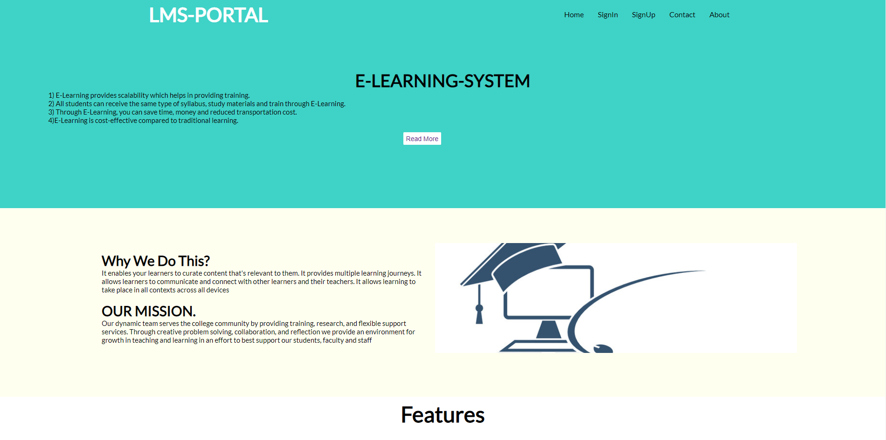

Signup page:

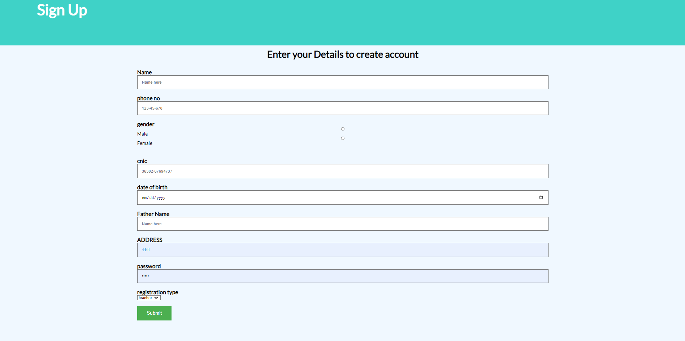

Boundaries:

* Name and Father name cannot be a number.
* Phone Number should only be a number.

Sign in page:

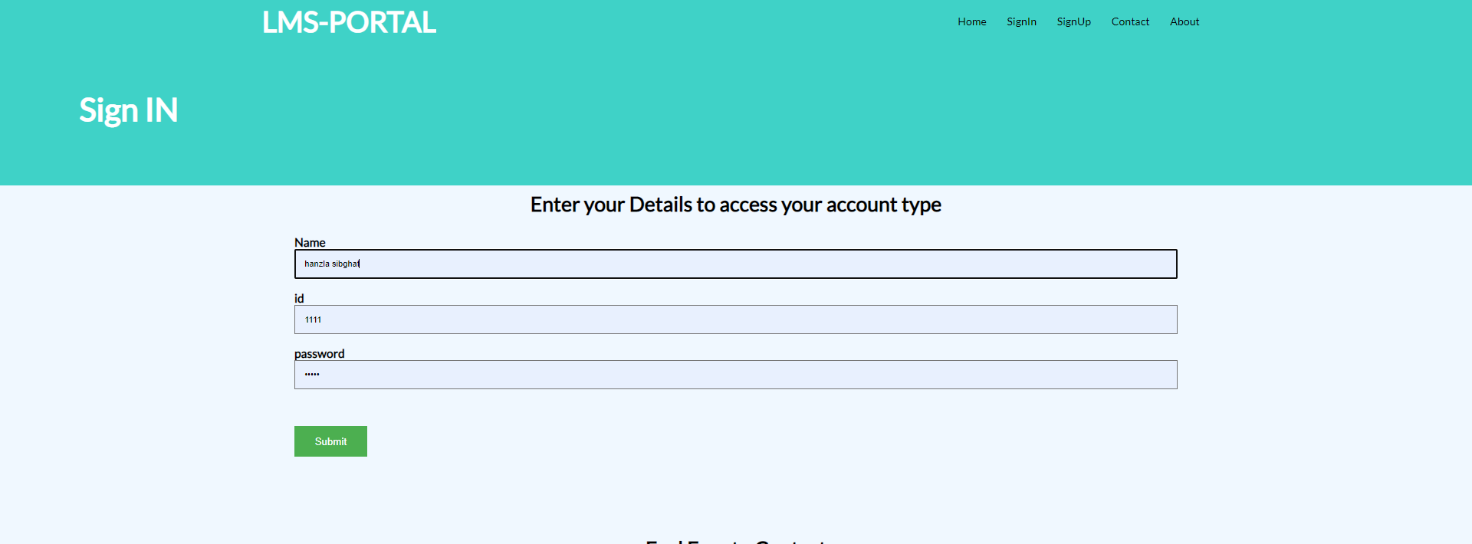

Boundaries:

* Name cannot be a number.
* The data input should be present in the database otherwise user wont be able to login.

Boundries:

Check exam:

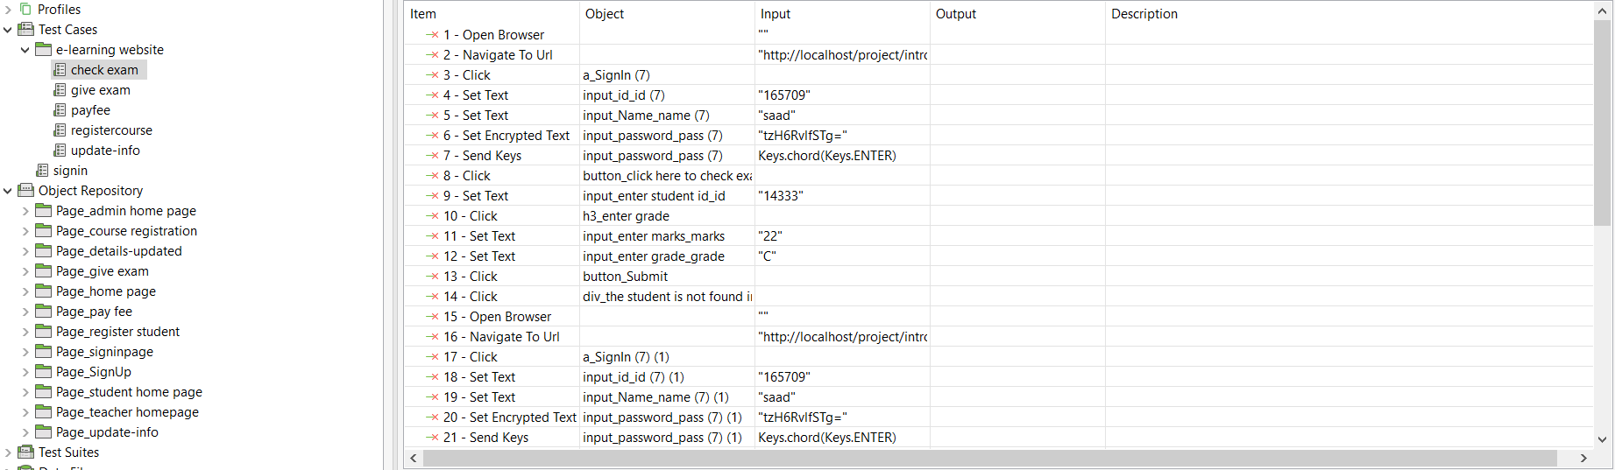

Give exam:

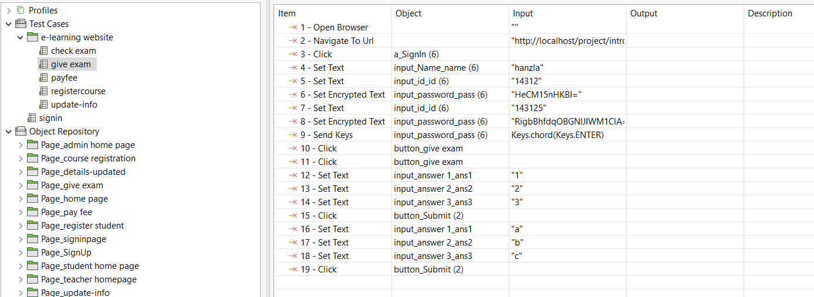

Payfee:

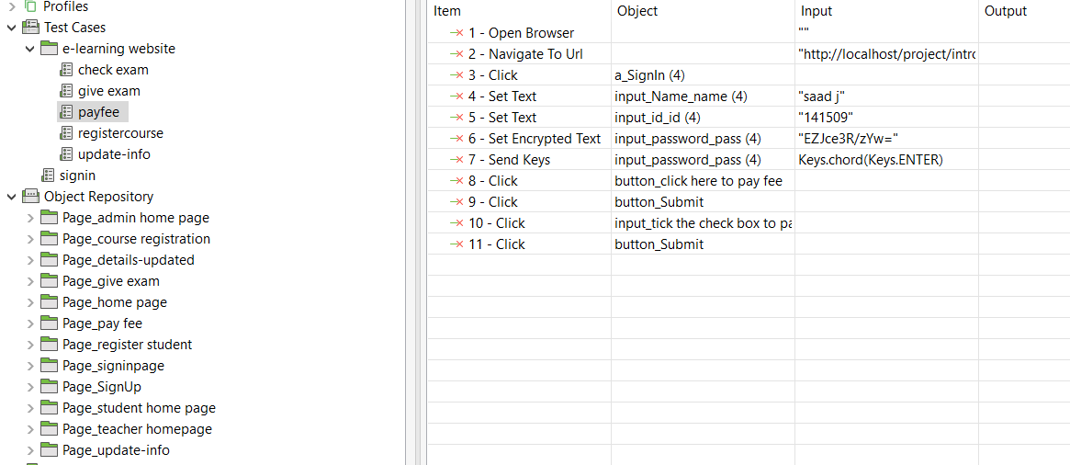

Register course:

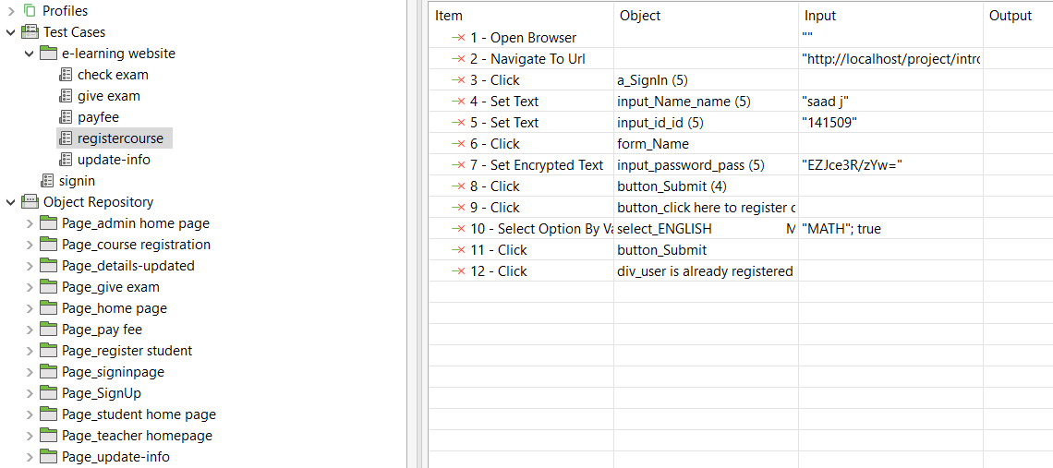

Update info:

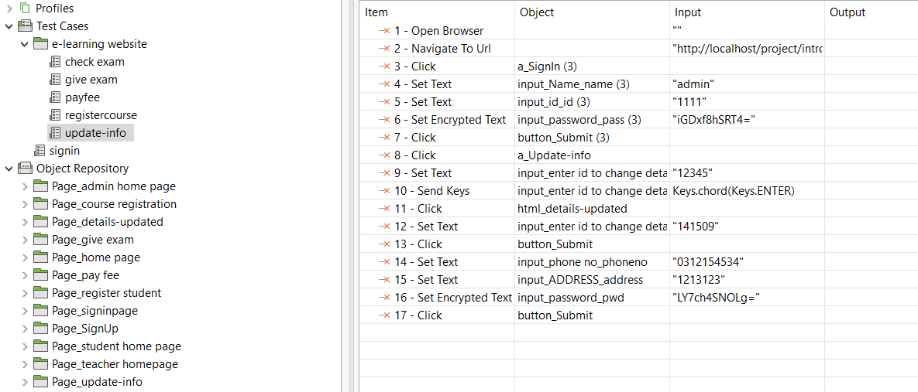

Signin:

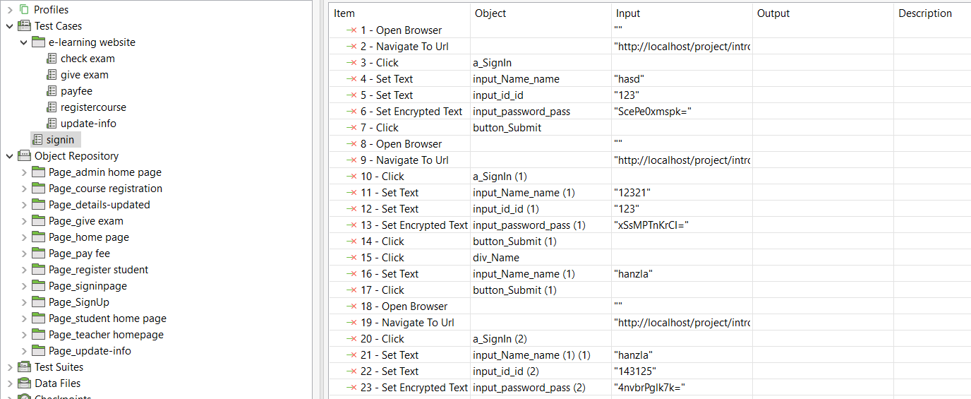

Student page 1:

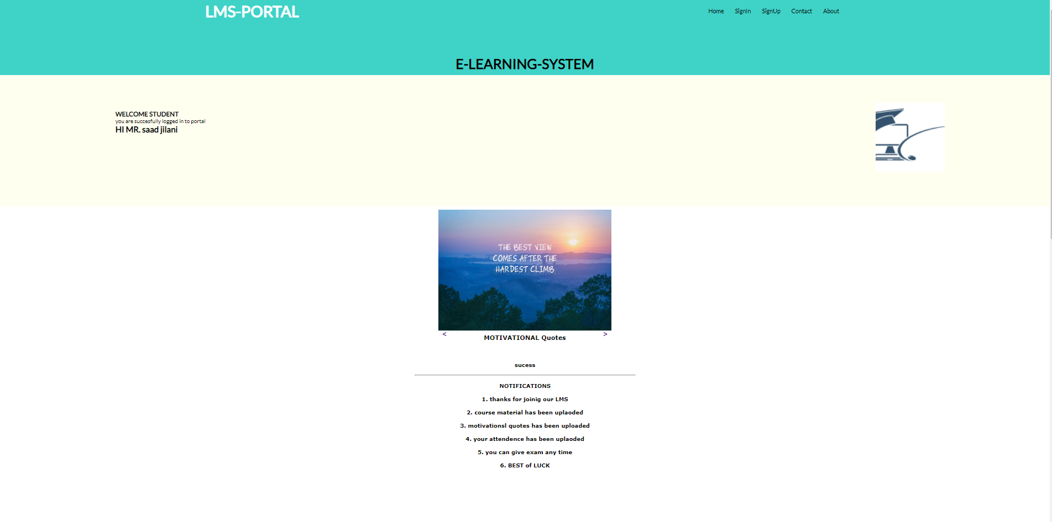

Student page 2:

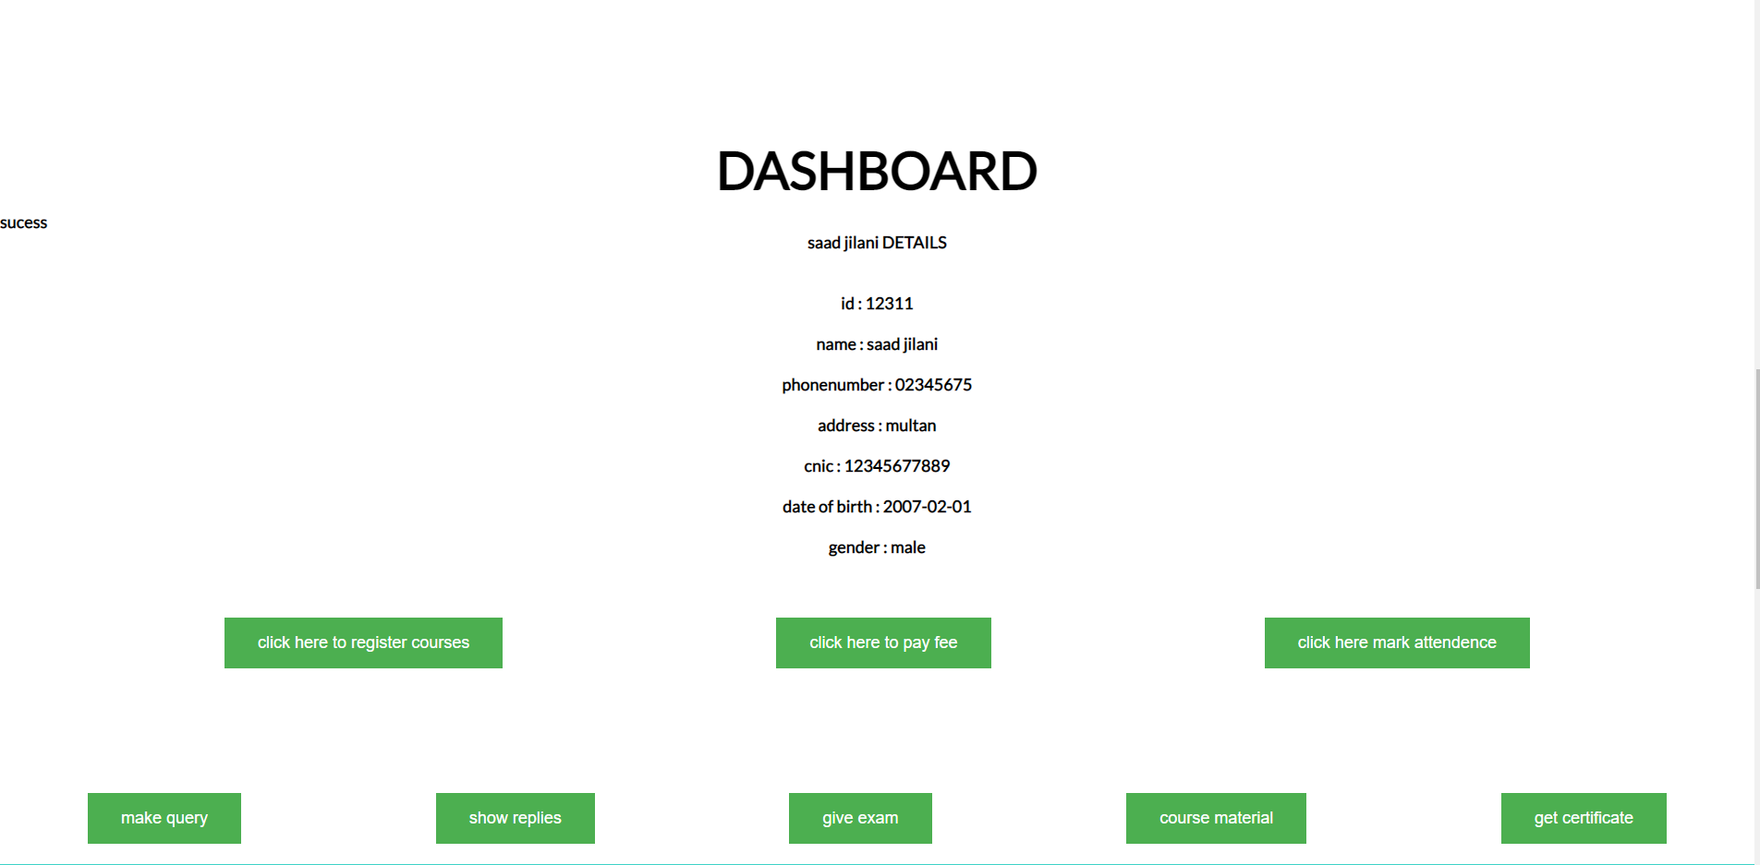

Course registration course:

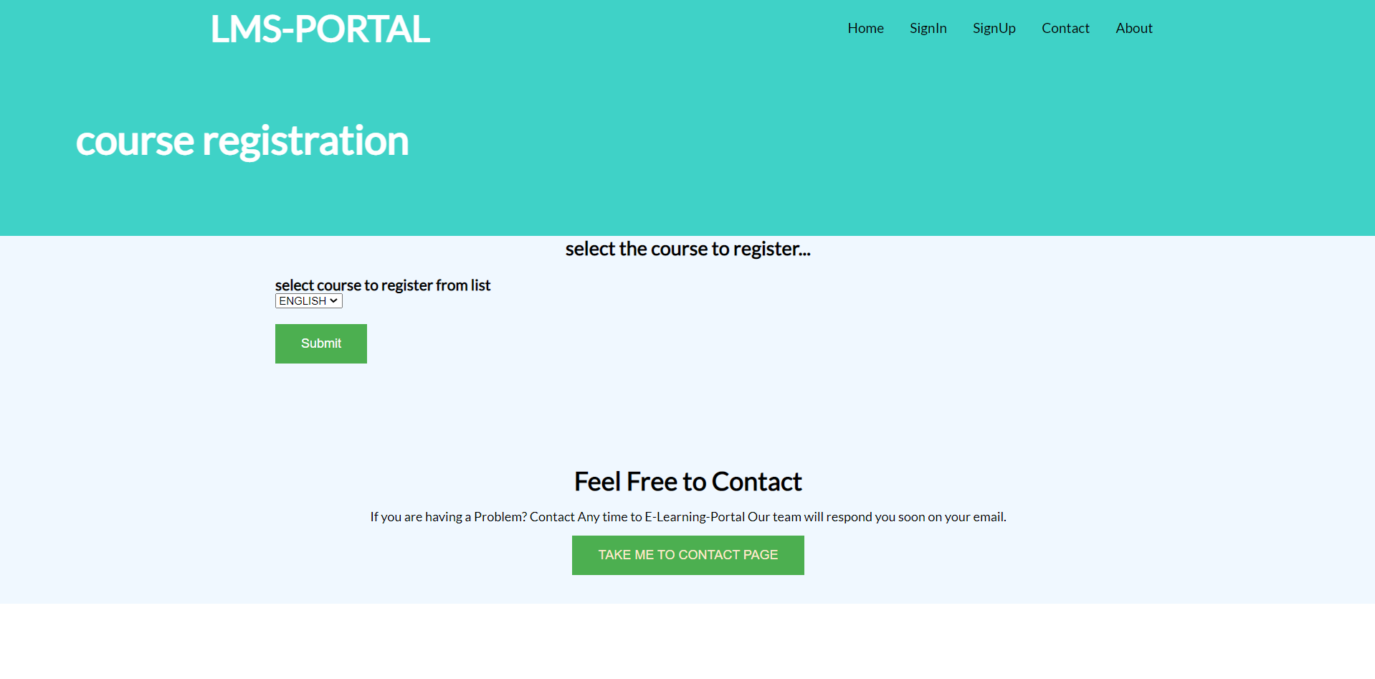

Pay fee page:

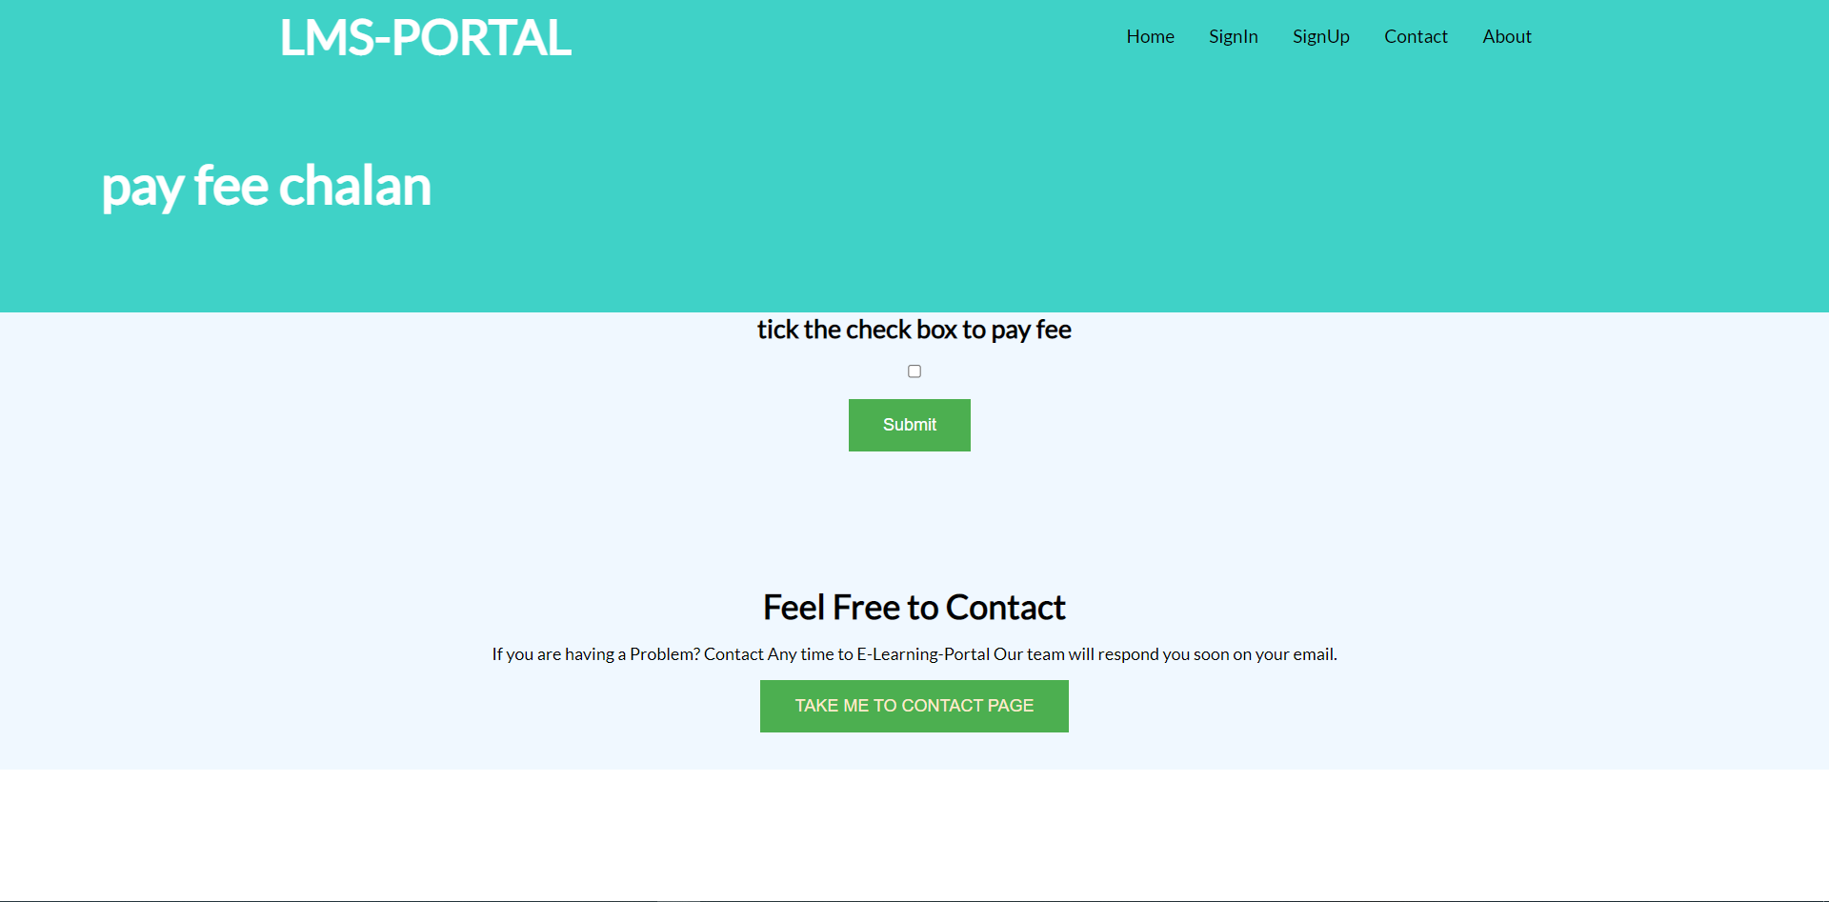

Make query page:

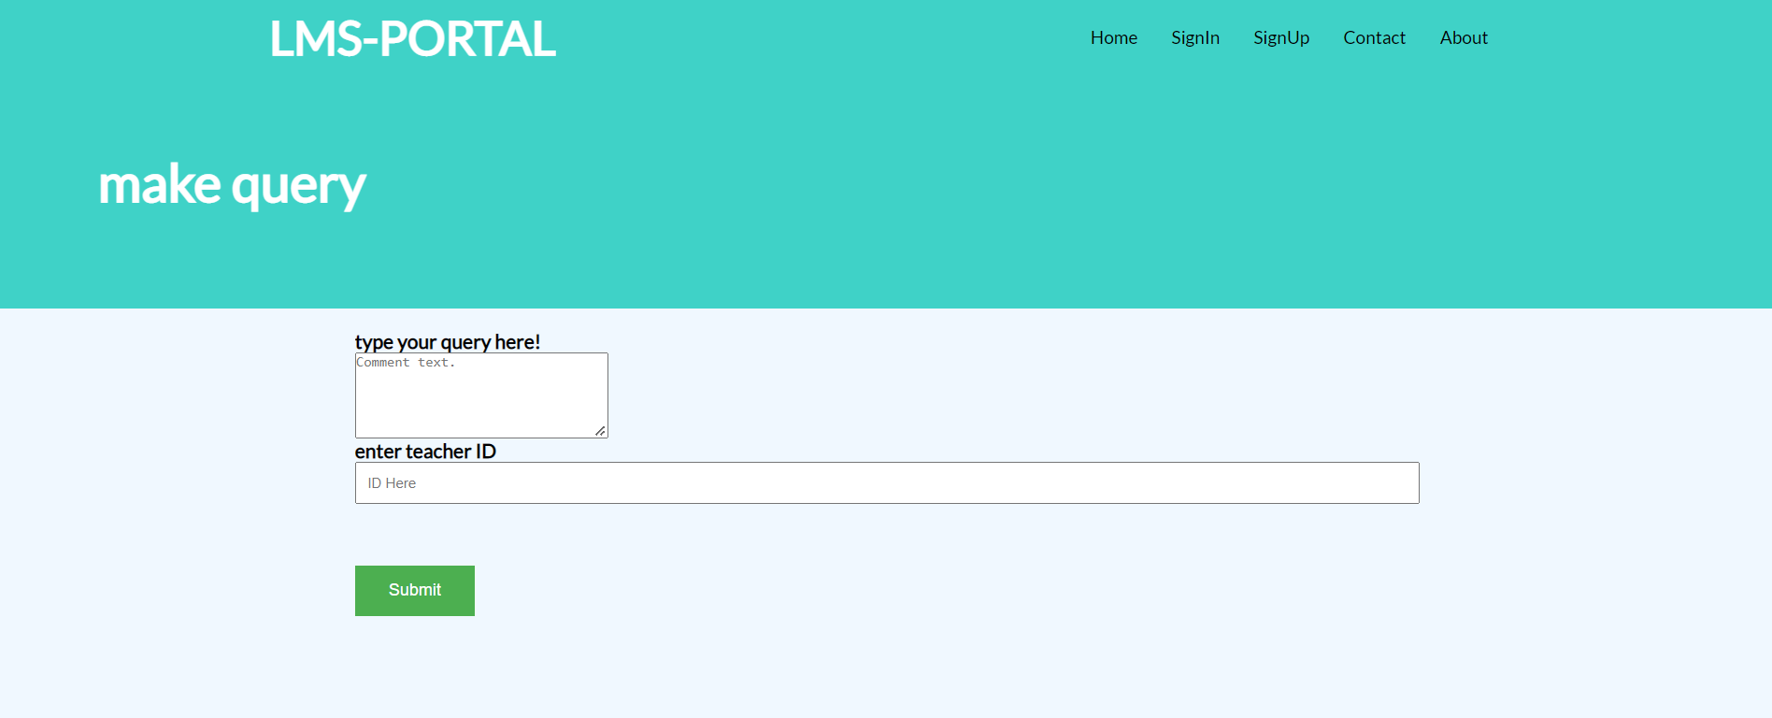

Boundaries:

* Teacher ID should be present in the database otherwise query wont go through.

Give exam page:

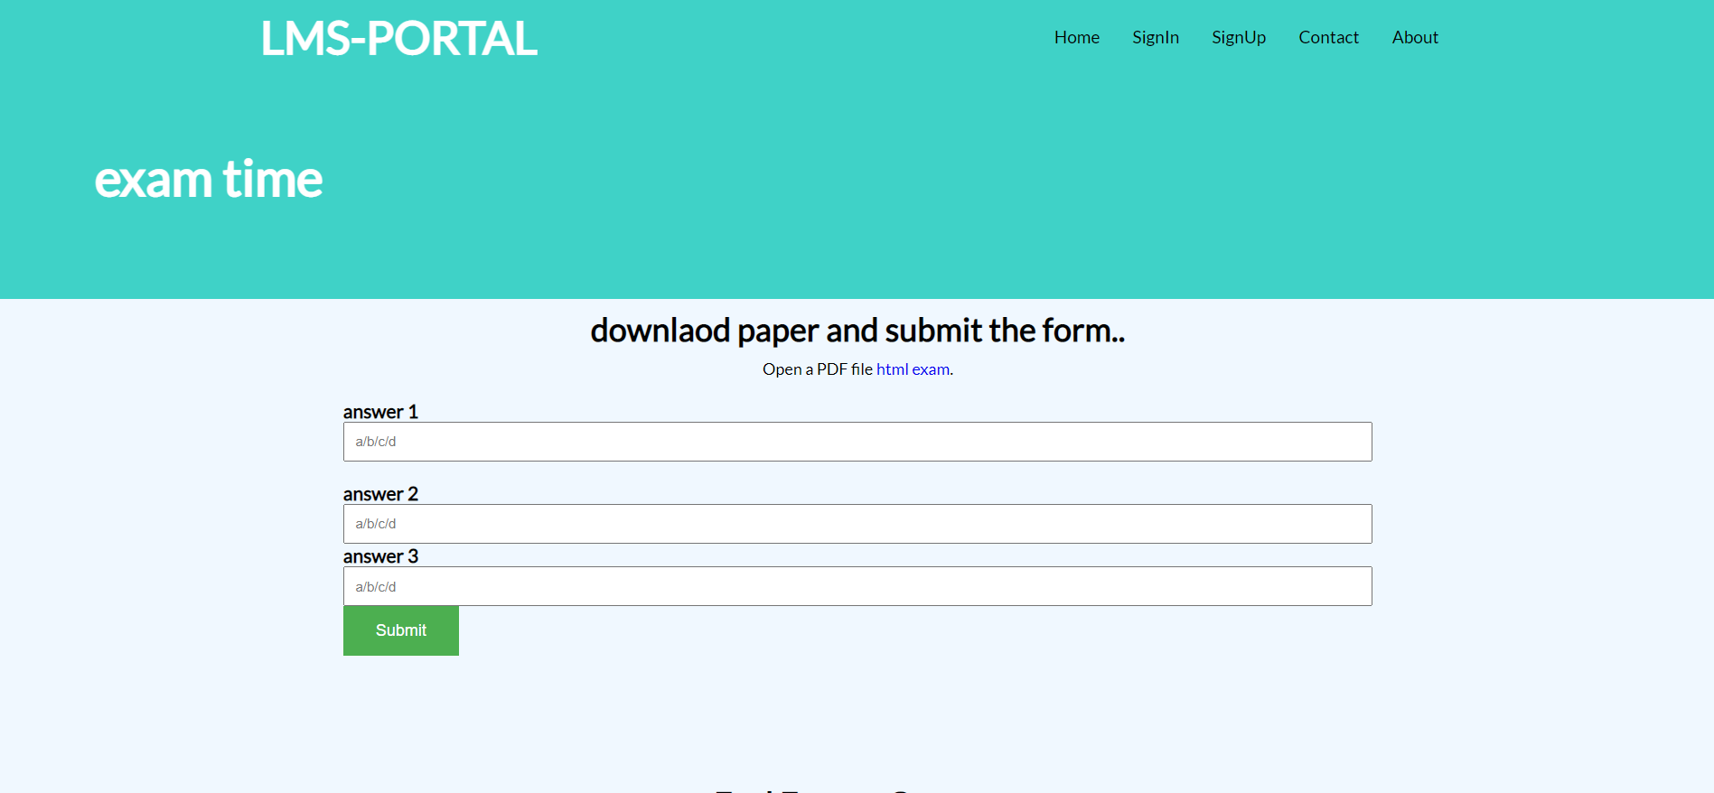

Boundaries:

* Only Single alphabet can be input in the answer slots.

Course material download:

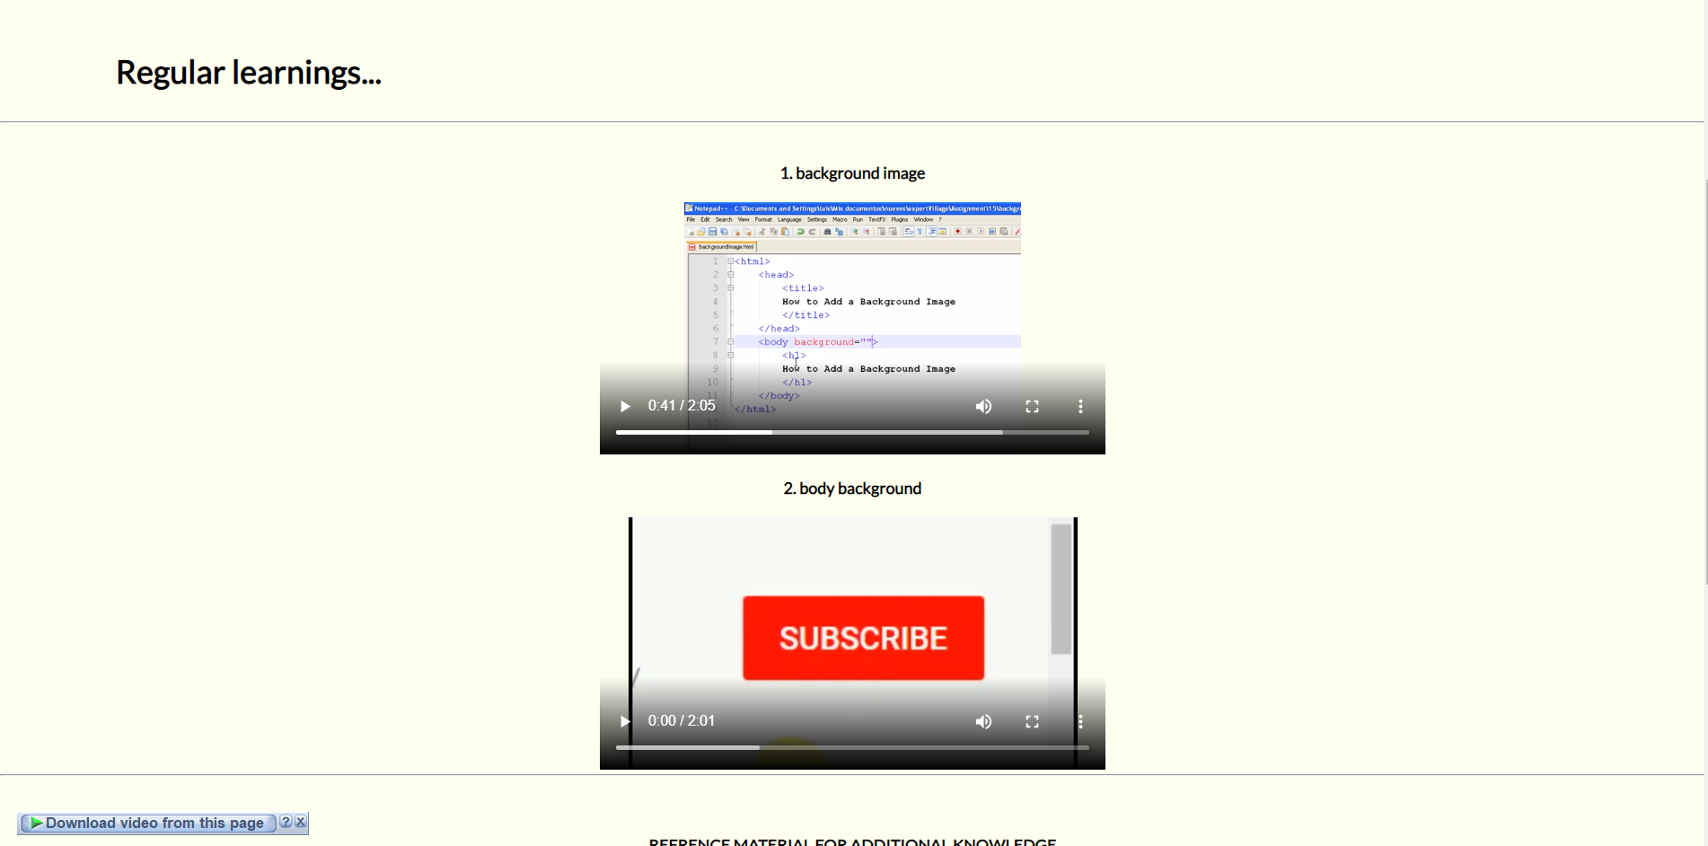

Teacher page:

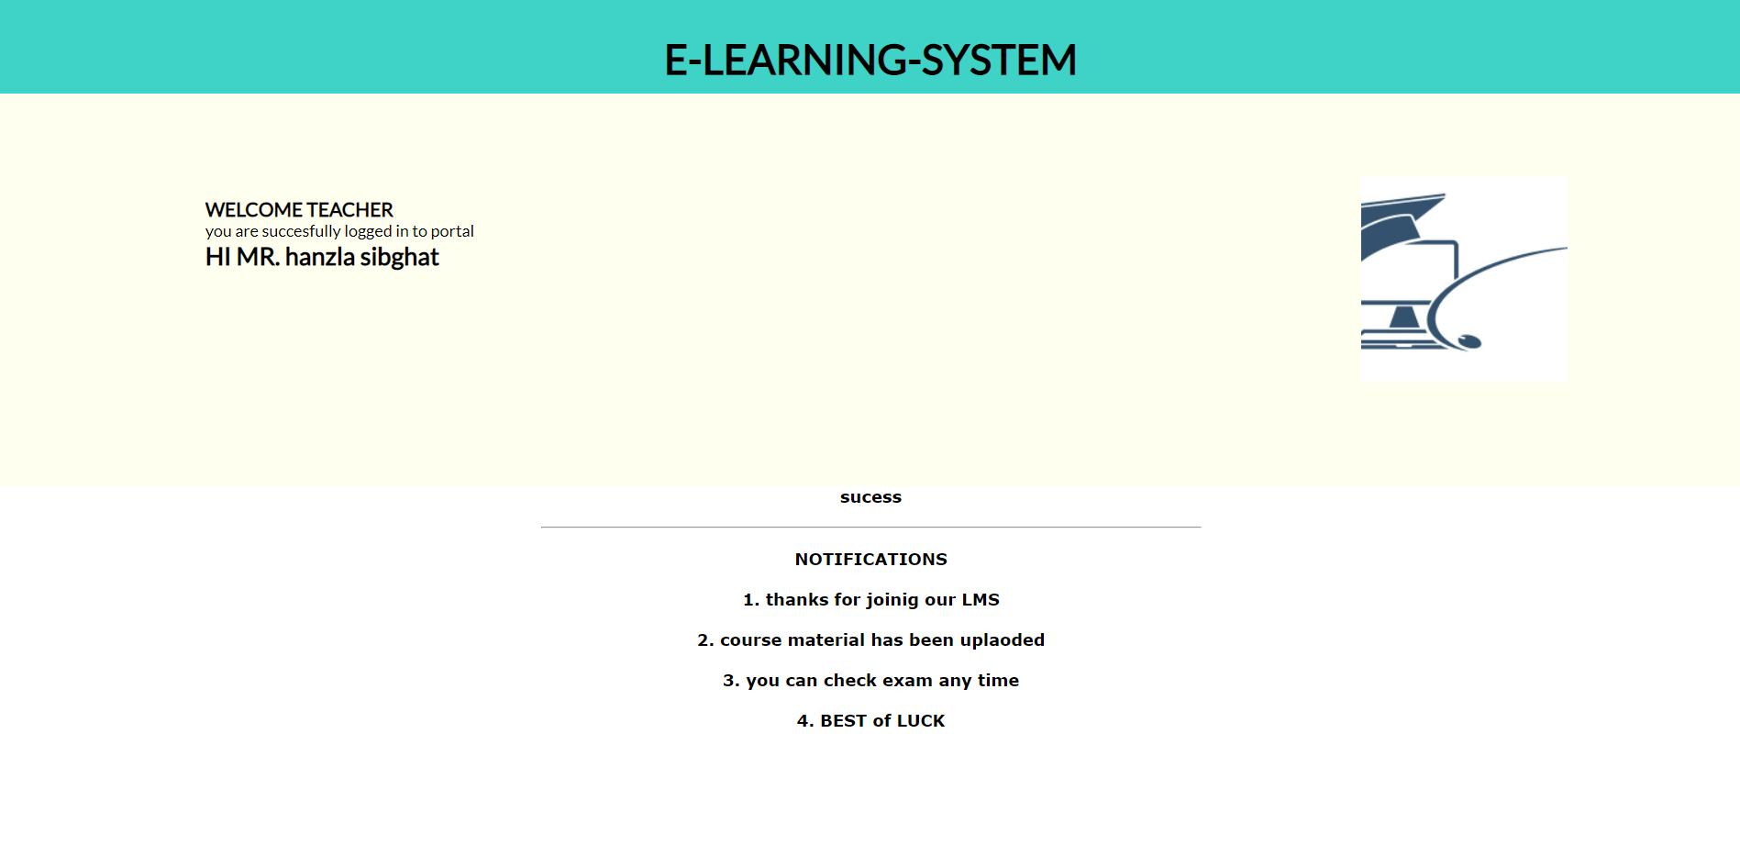

Teacher course registration:

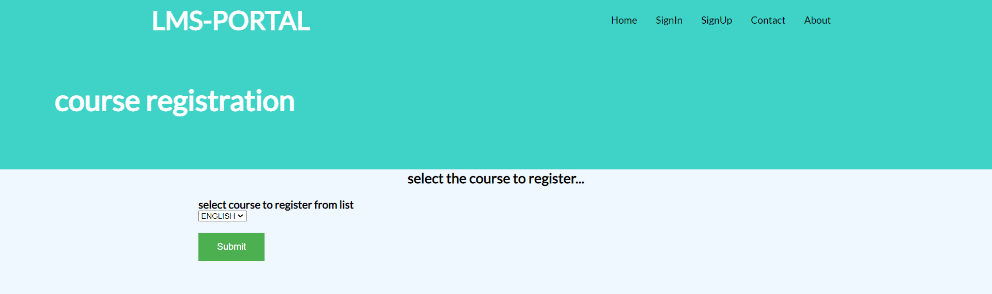

**9. improvement:**

we can improve the GUI and we can additional features which are not necessarily a requirement but can be an extra feature for customer to use. we can use mongo DB and react to make the GUI more user friendly and interactive and can add tutorial messages for the new User so they can explore the features. We can decrease the number of pages also which can make it more compressed.

**limitation:**

We have added almost all the features the LMS can have. So, adding more features such as games for quick learning etc. can make the LMS complex to use.